Q 1.Create user shubham.only shubham can launch ec2 instance in Mumbai region

🡺 Step 1:- Firstly open aws account and then search Iam service on that and click on that

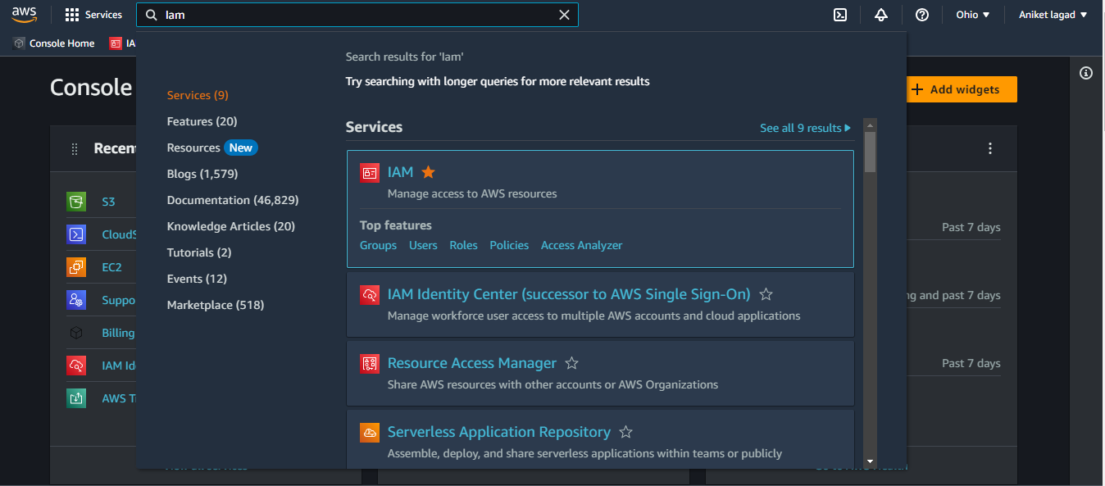

Step 2:- Then Click on users and next click on adduser options

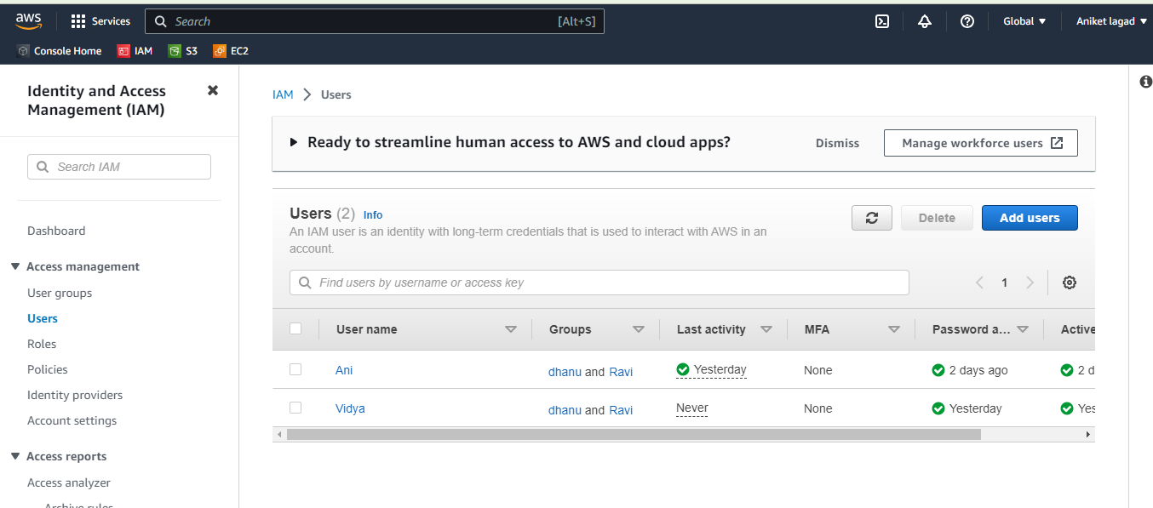

Step 3:- Then enter username and user details and then click on next

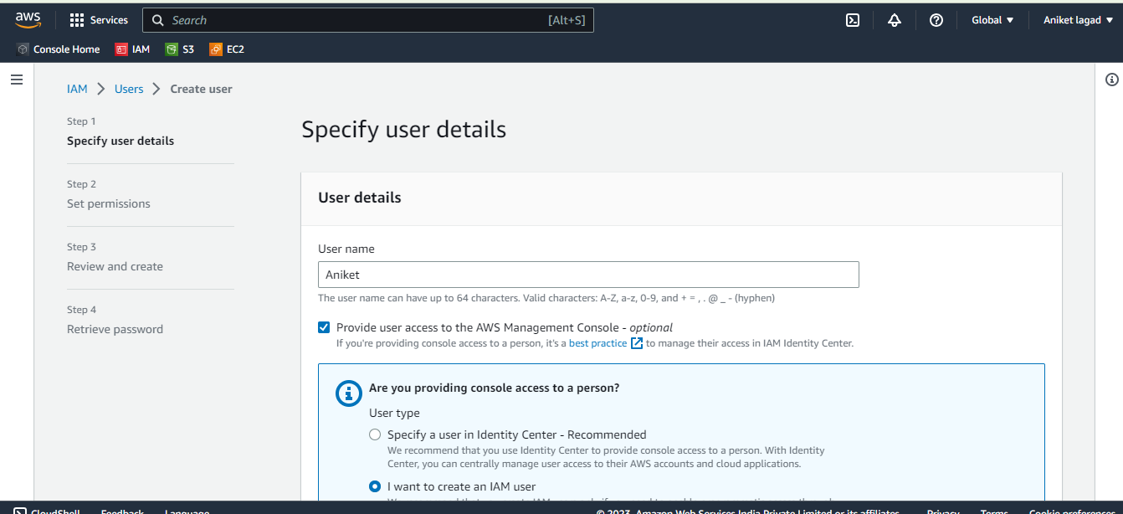

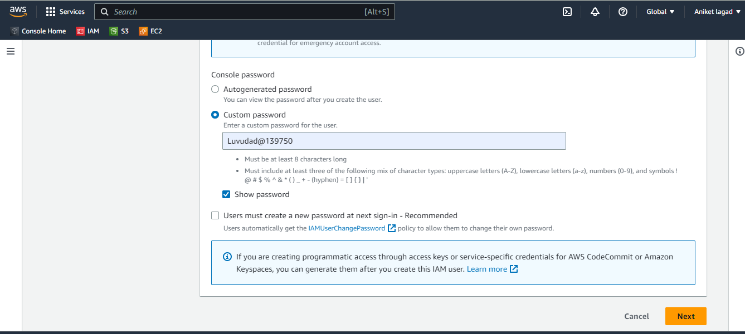

Step 4:- Now we want gave permissions or we can say policies to user so u can gave access on any metod that avalaible. We create policy customiged policy so selecet on create policy

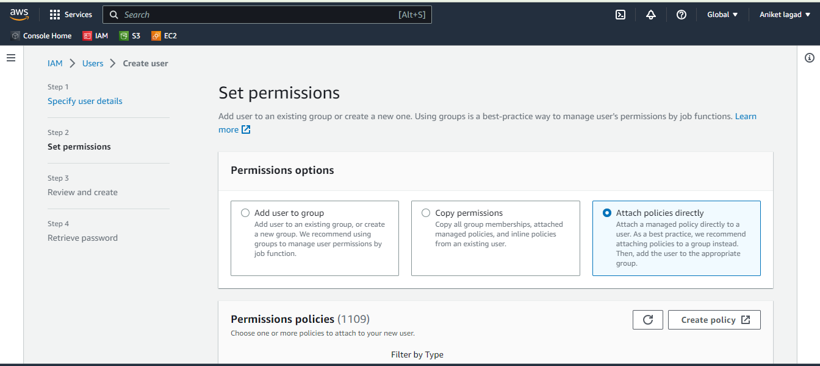

Step 5:- we will create policy by json.

So we want gave permission to user shubham to create instance in only Mumbai region so we create json policy by aws policy genreater and create a policy

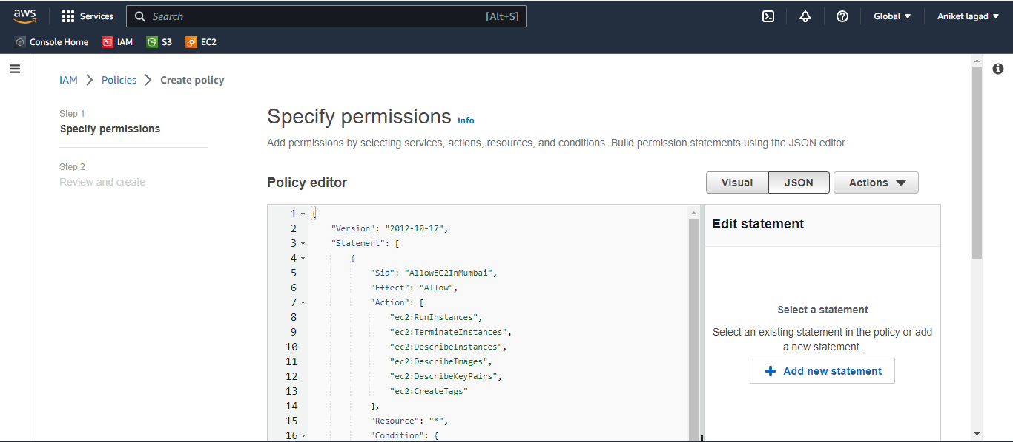

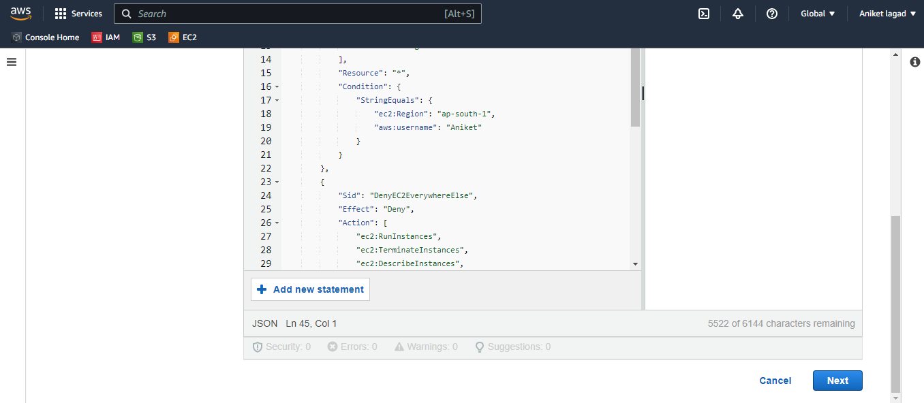

Step 6:- Then gave to policy a name and go down side and click on next.

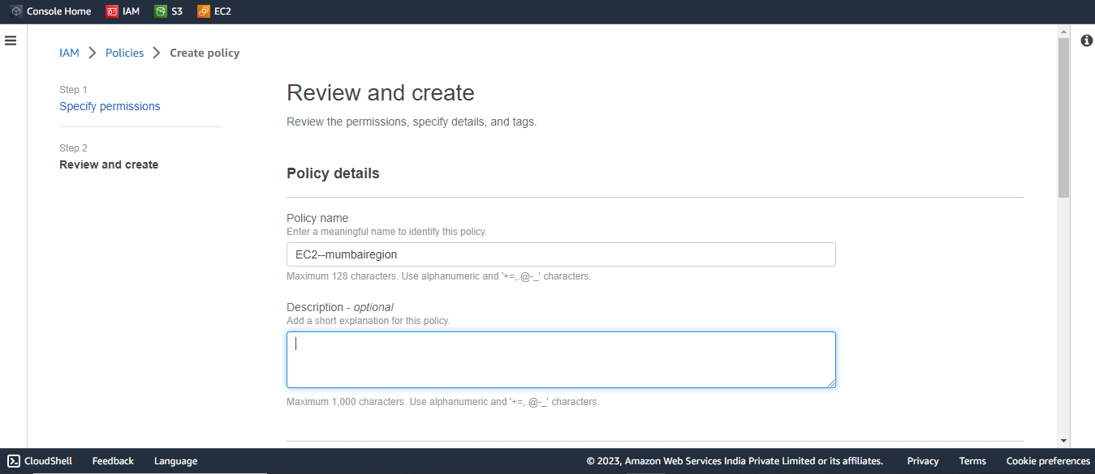

Step 7:- And then apply a permission which you created and click on next

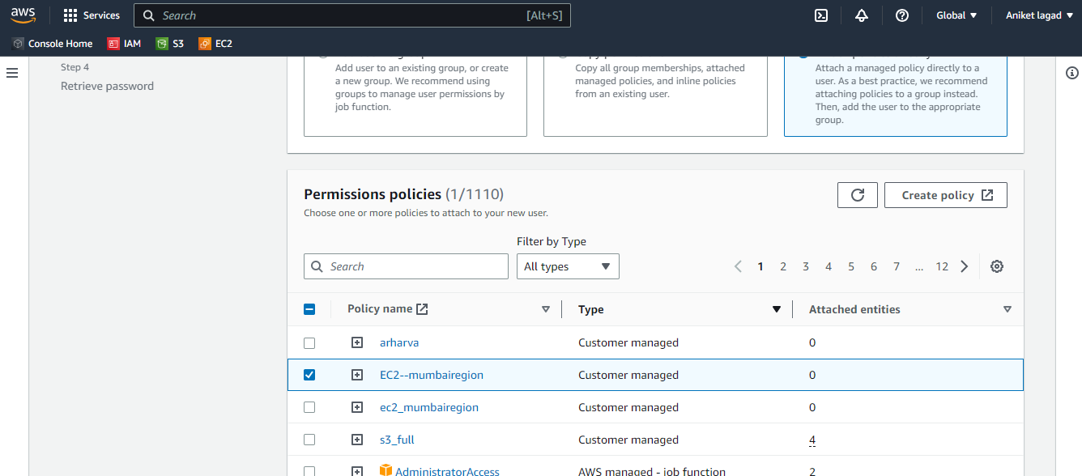

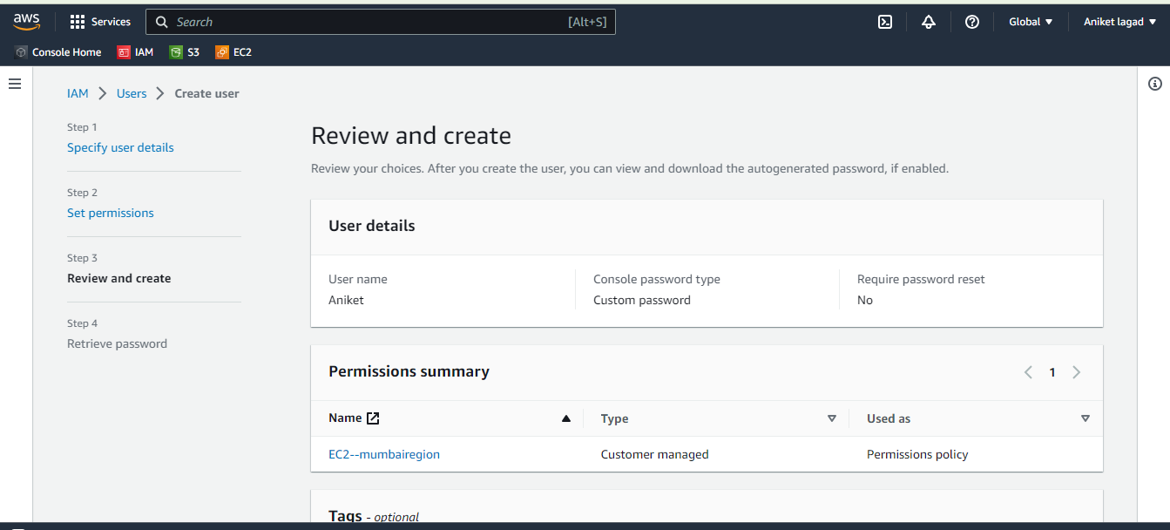

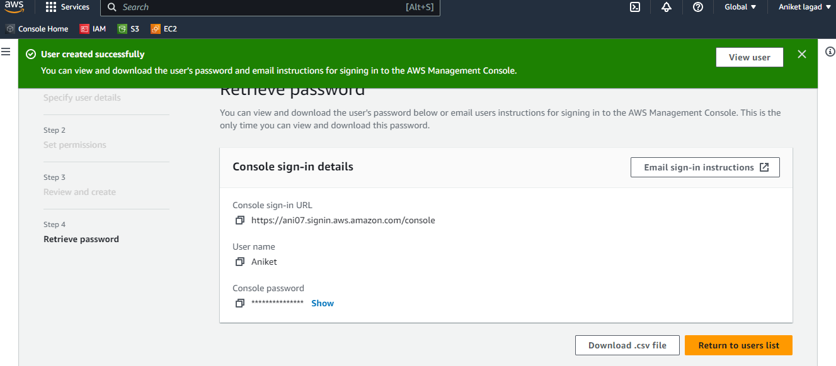

Step 7 :- Now login into that user to see he has apply that policy or not .

Login by concole link and go to ec2 service and create instace in Mumbai reagion and see it has access or not .

Q 2.create S3 busket and share it with another account

🡺 Bucket means a data storeger of services or servers

Step 1:- Open aws account and then run s3 service for create bucket

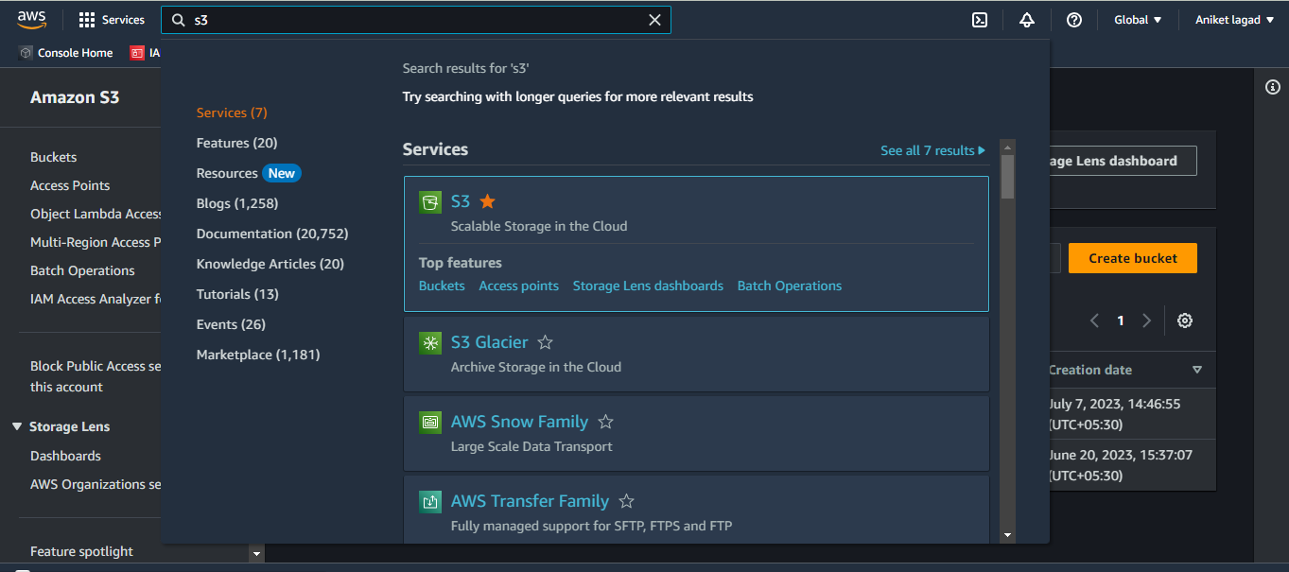

Step 2:- Now clicke on create buckets option for create bucket.

Then u want to write a bucket name with a unique name it means it will be not used anyone before

And then select region.

You will create bucket in particular region. Bucket is made for only region wise.

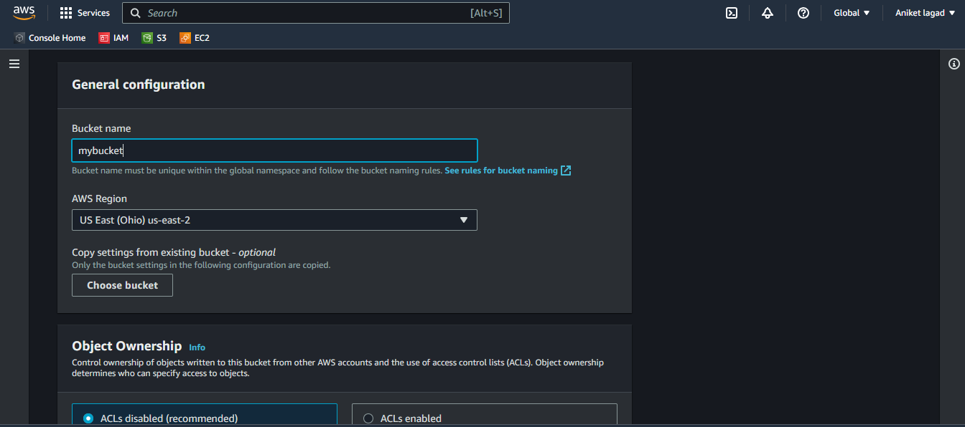

Step 3:- Next u want select acl means access control lists to bucket for give a access to particular user or resources.

And then select object ownership means who can access bucket owener of bucket or writer of bucket.

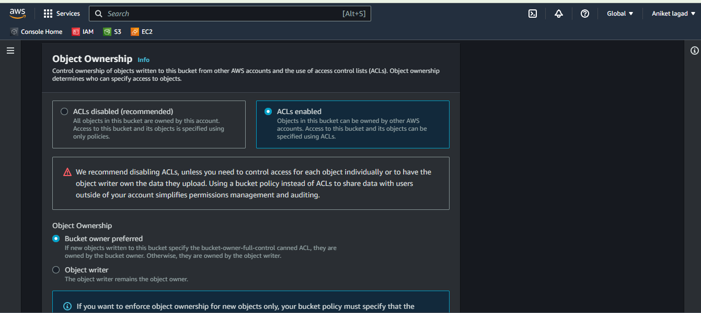

Step 4:-select if u want block access for public or open access for public.

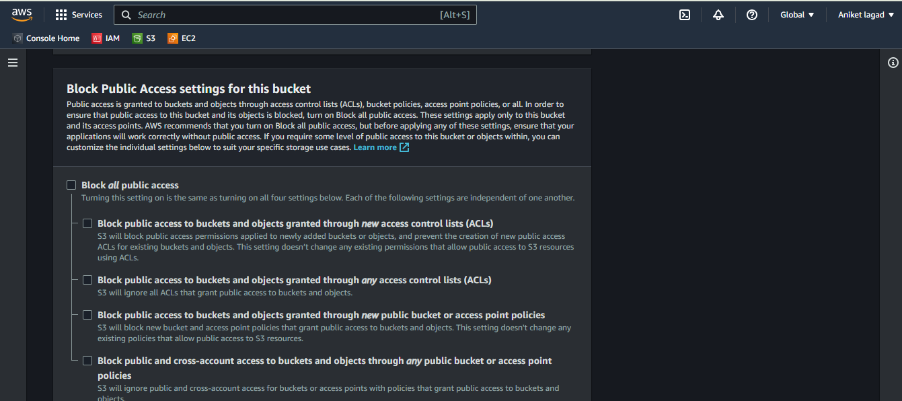

Step 5:- Next option is bucket versioning it means in bucket u can add same names files upload.

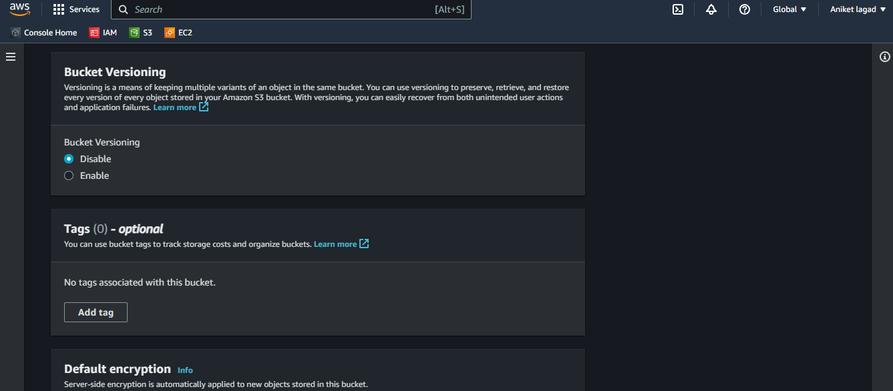

Step 6:- By default encryption option u can send and store data in encrypted from.

And also u can create a bucket keys.

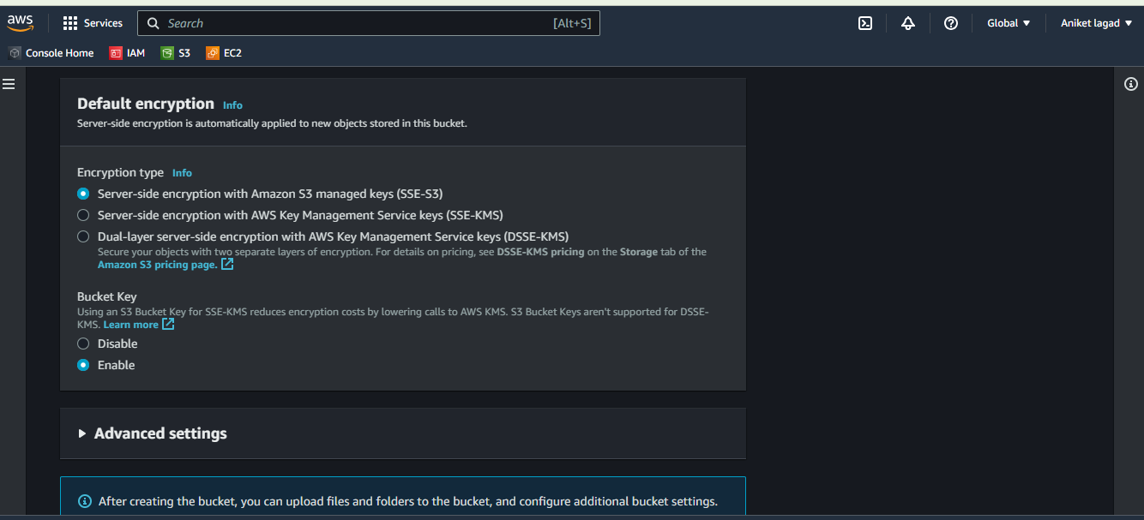

Step 7:- Advance setting is used for lock data beacause no one can delete data.

And then create a bucket .

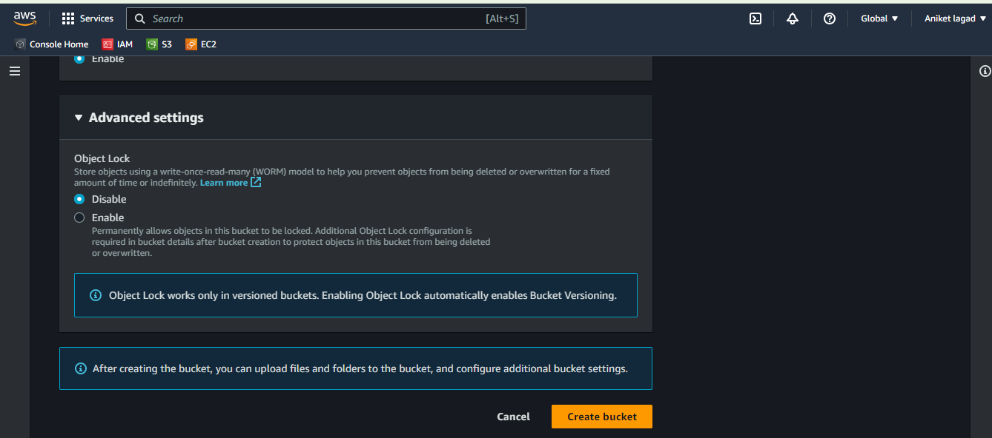

Step 8:- Now you want to gave access of bucket to other user or your user so u can create role of it and gave role to user so user can switch role and get access of bucket.

Go to iam service and then click on roles and then click on create role

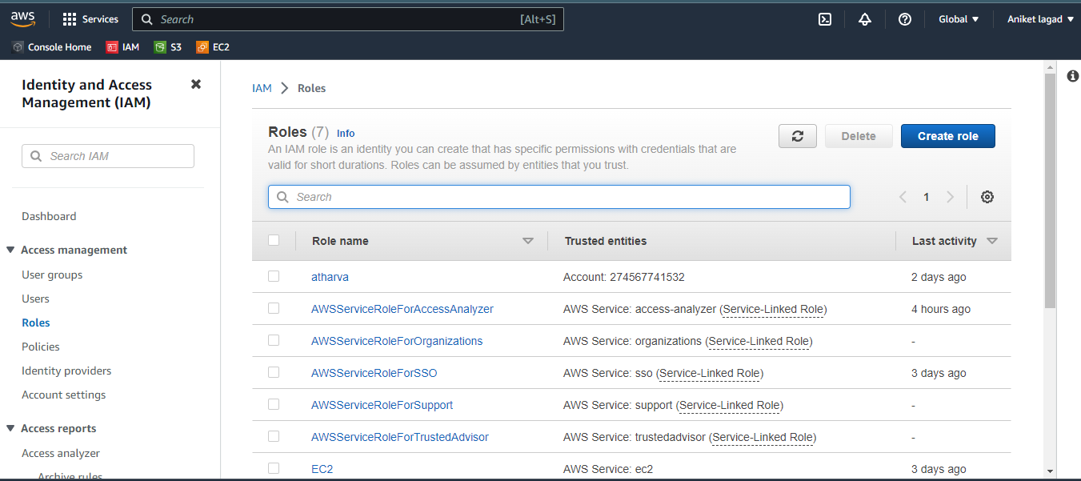

Step 9 :-Now u want click on aws account and then select this account gave role to your account user and another aws account to other account user.

So I am choose this account means my account and then click on next.

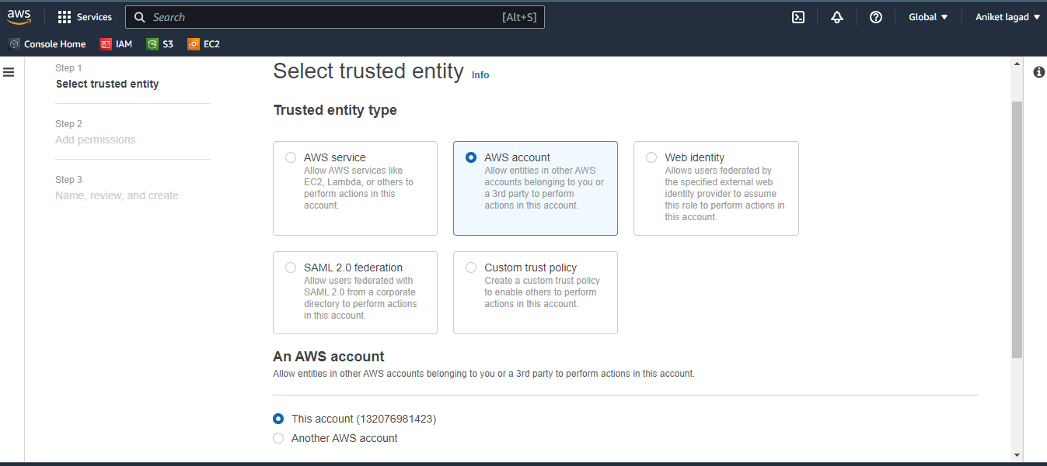

Step 10:- now you want gave a permission to that role by create policy or aws policy also you can gave directly I choose create policy

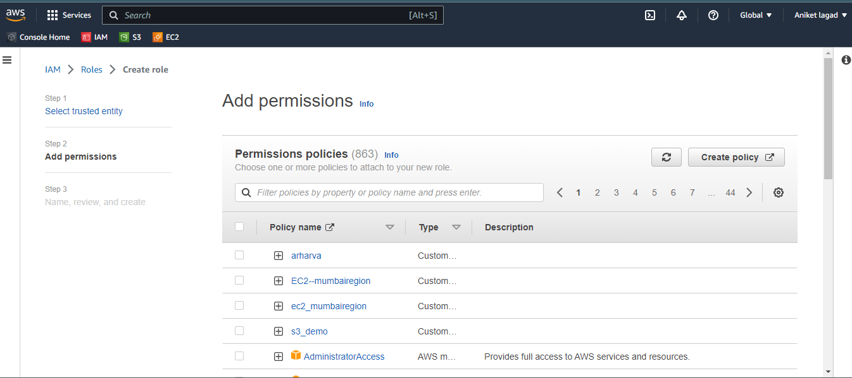

Step 11:- Then choose a permission of s3 service. In that select listallmybucket.

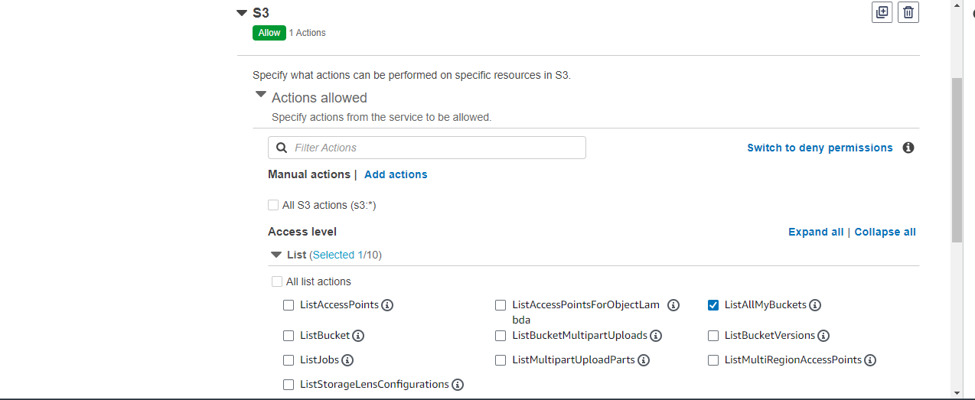

Step 12 :-Next select read option and in that get object select.

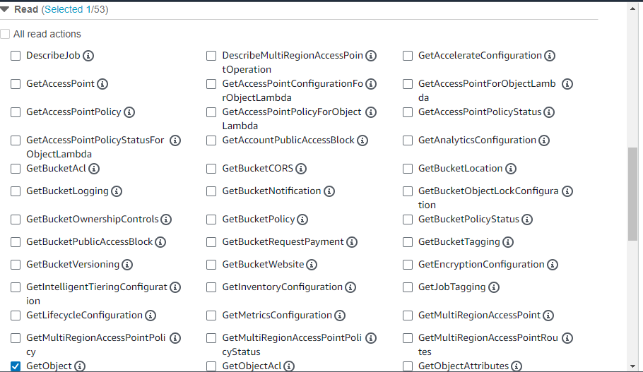

Step 13:- Next select resource and add your bucket ARN .and click on next.

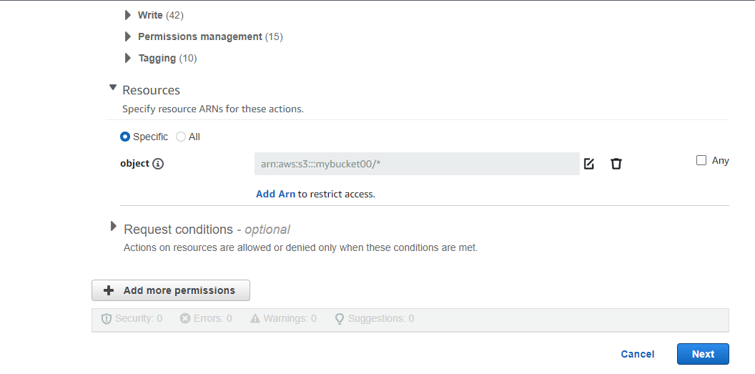

Step 14:- Now give a role name and create a role .

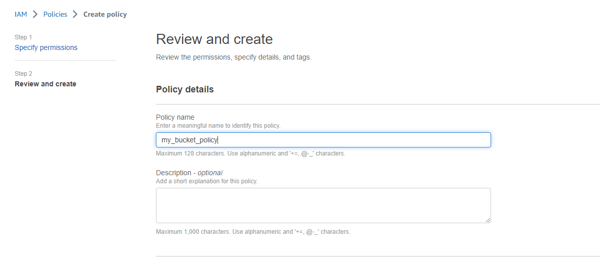

Step 15:- After that logging to your user account and then swtich role from that and you will see the bucket access fo your bucket .

Q 3.craete user linux. Linux user can only read demo bucket contains

🡺 Step 1:- go to iam service and creatae a user with name linux .

See following process to create linux user.

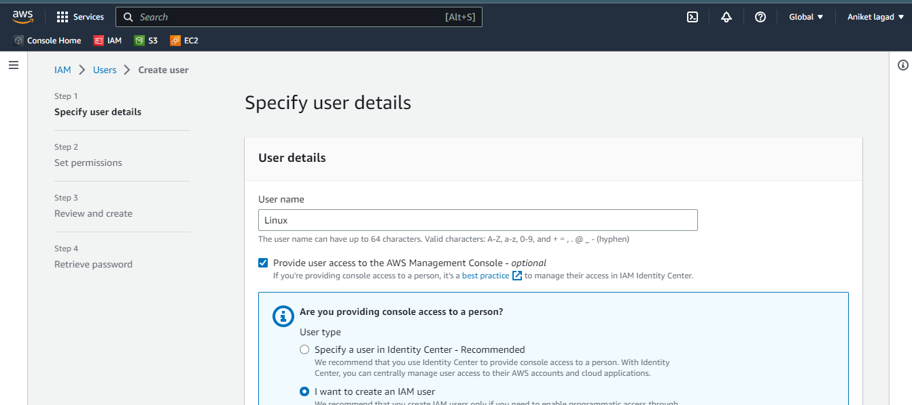

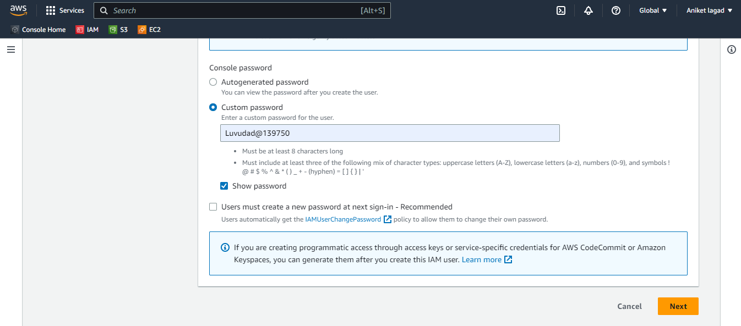

Step 2:- Then u want to create to bucket with name demo and upload data in it.

Go to the s3 service and create bucket.

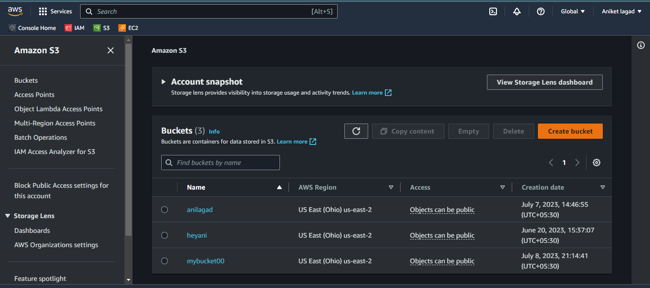

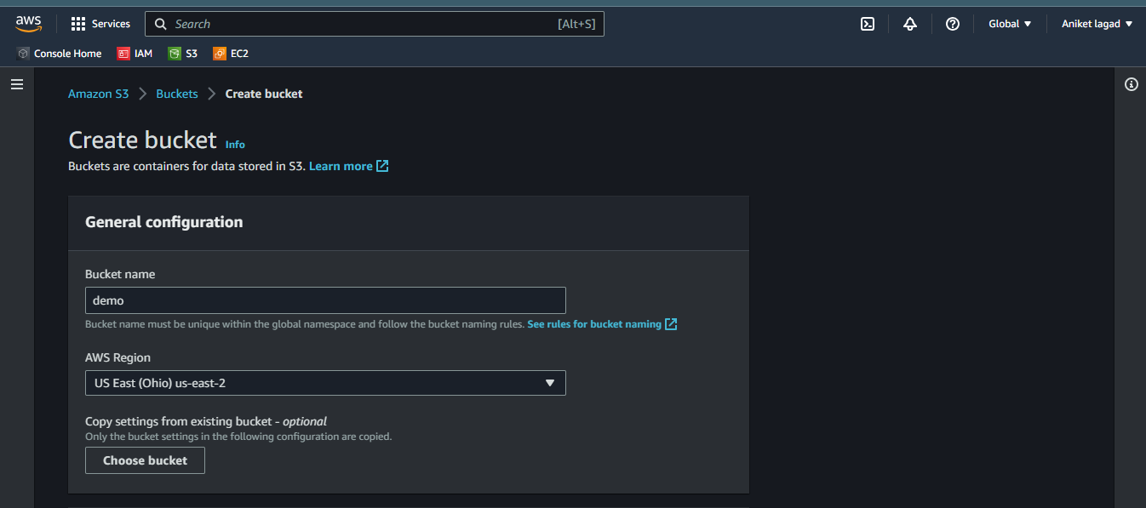

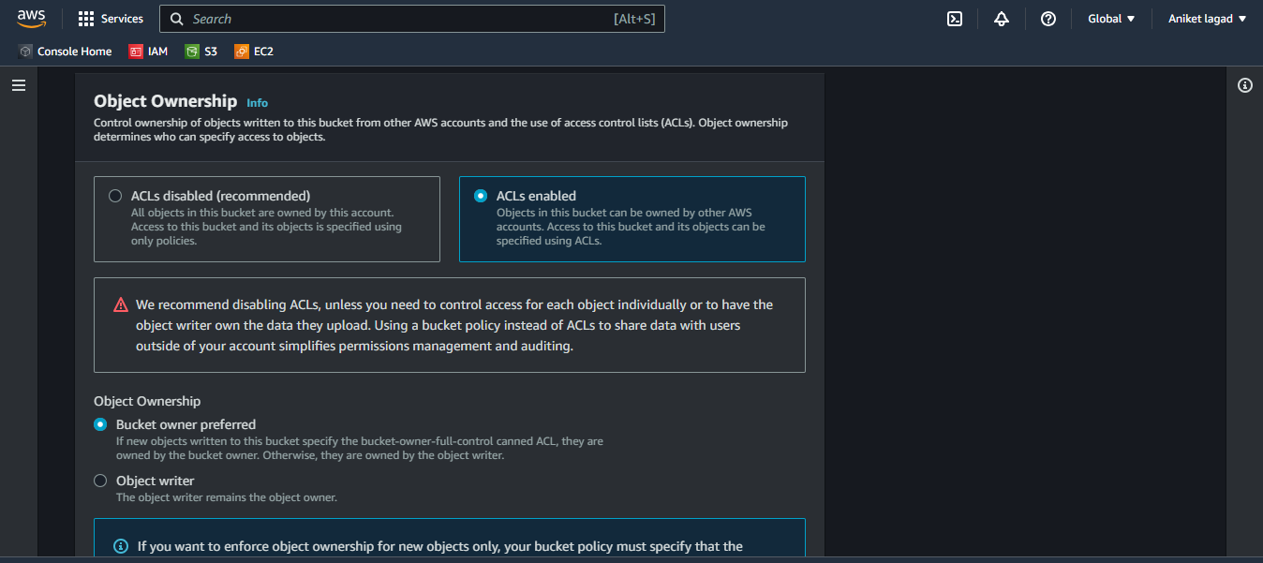

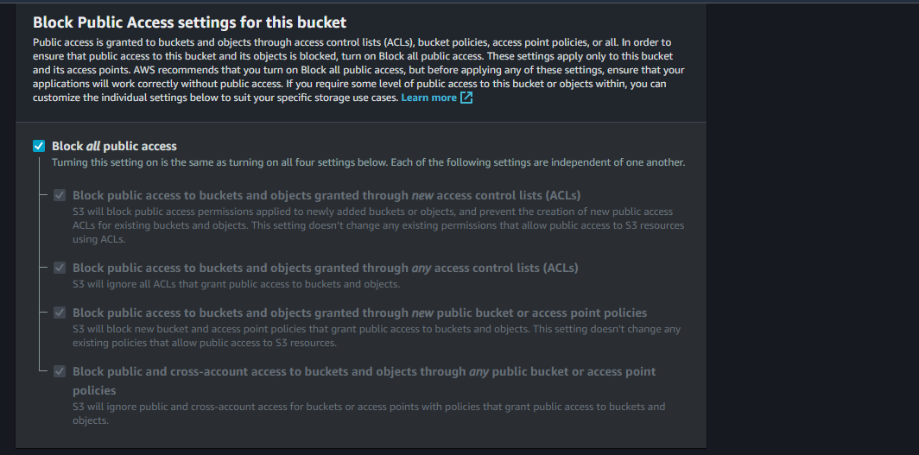

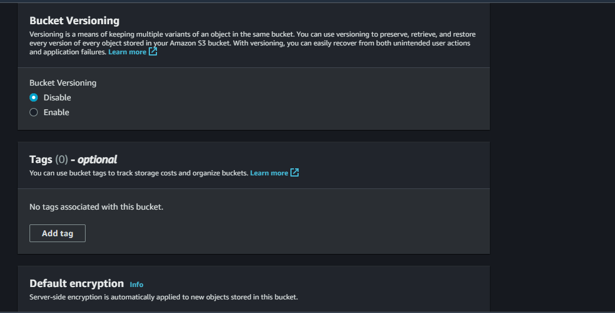

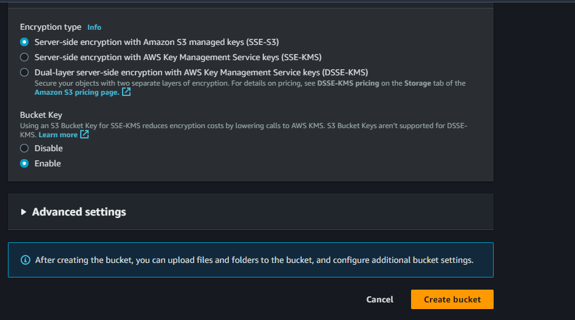

Step 3:- Now u want give access to a user to only read policy so you can give policy red only by 3 methods by visual,json and create role.choose any method to give policy to user read only policy.

So I gave visual policy.

Step 4:- Go to linux user and click on add permissions

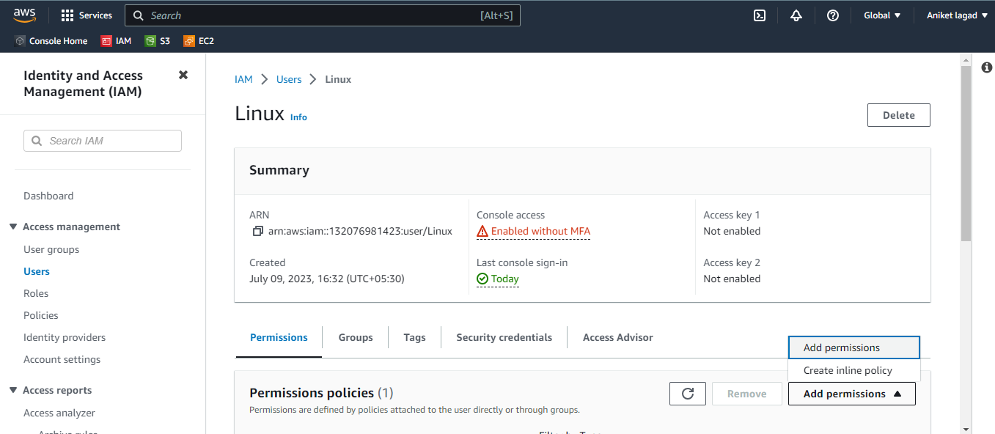

Step 5:- Then click on attach policy to attach a policy.

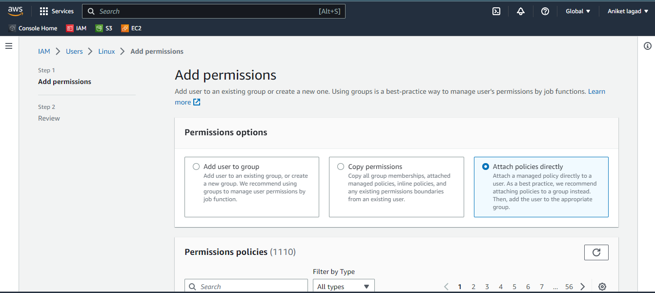

Step 6 :- First create policy by click on policies

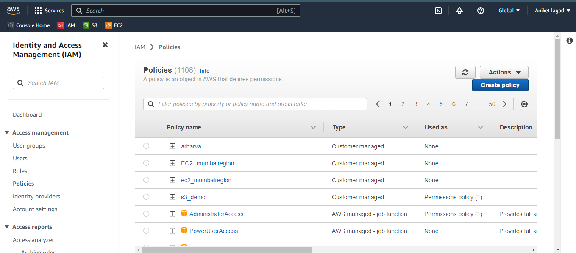

Step 7:- Then select permission s3 and in that list option and listallmy bucket

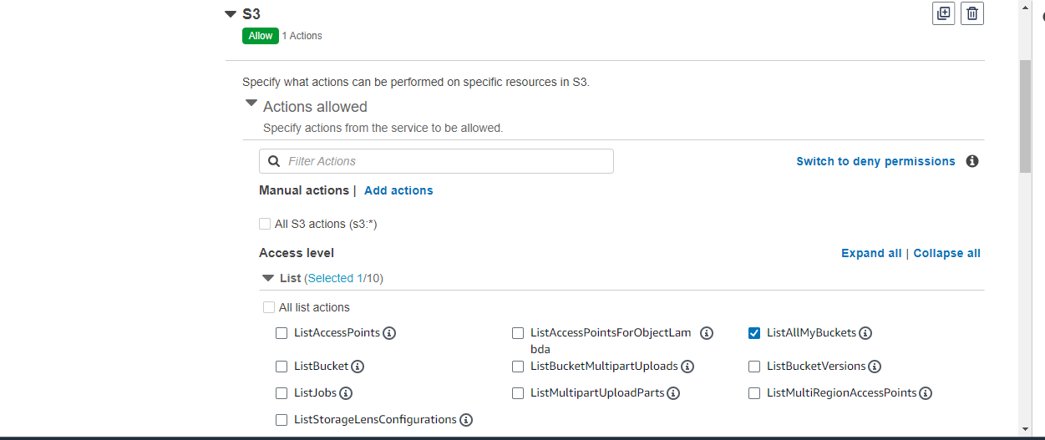

Step 8:- Then in Read option and in that option sub option is getobject select

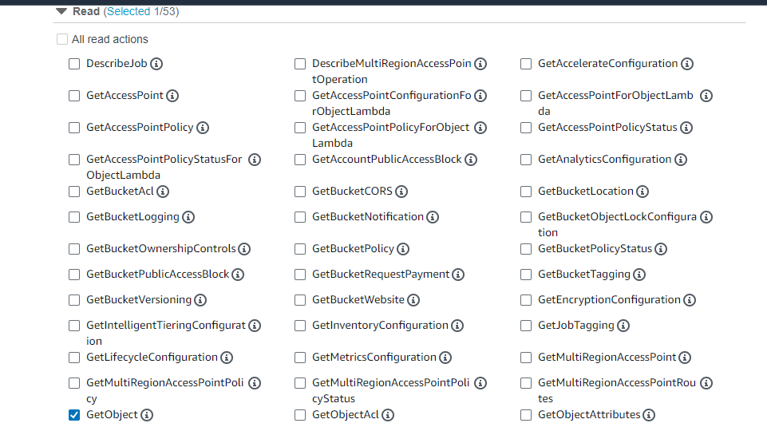

Step 9:- After that in resources option atumatical added a option object so only punt in that object option ARN of your bucket and click on next and gave a policy name after that click on create policy and your policy was created.

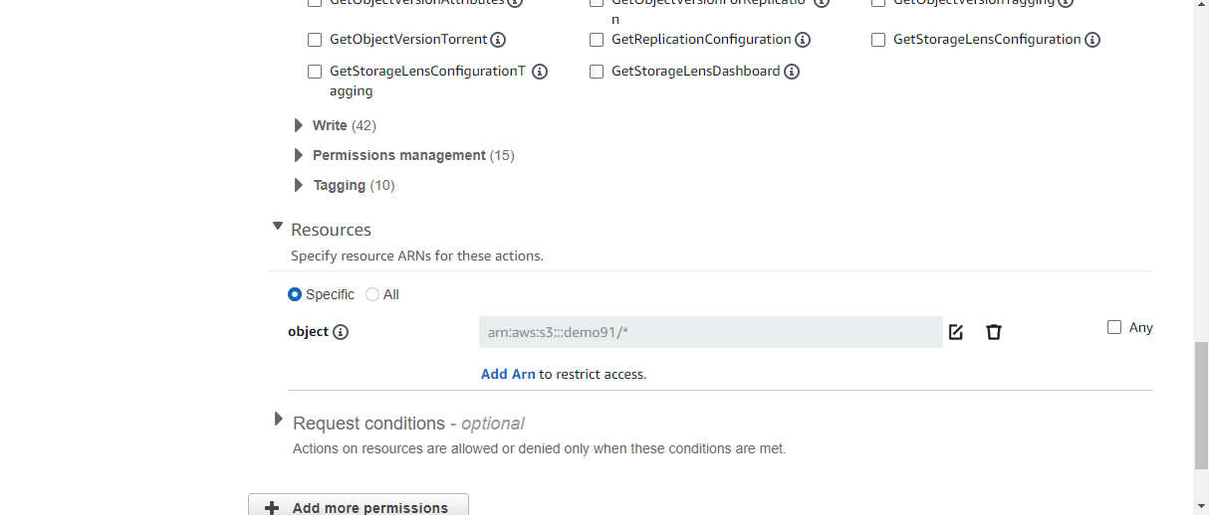

Step 10:- Now attach your customized policy to user linux and click on next.

After that review page is show read that and click on add permission.

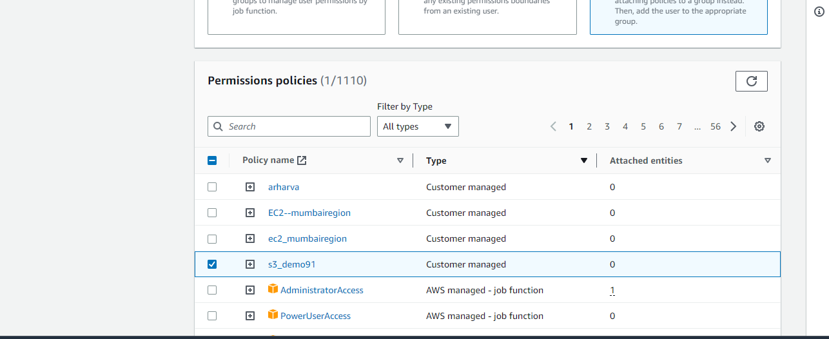

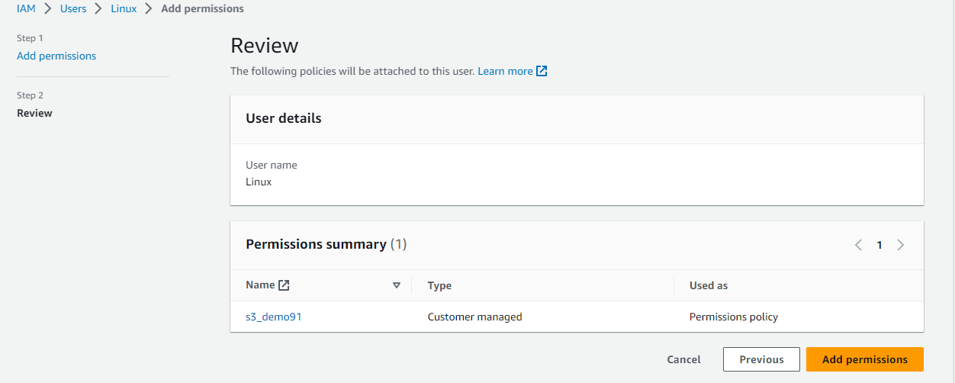

Step 11:- Now your user linux has attached a policy of only read bucket contained policy.

To see linux user has get permission of read bucket demo or not logging to linux user account by console url.

Copy console id from linux users information security credentials.

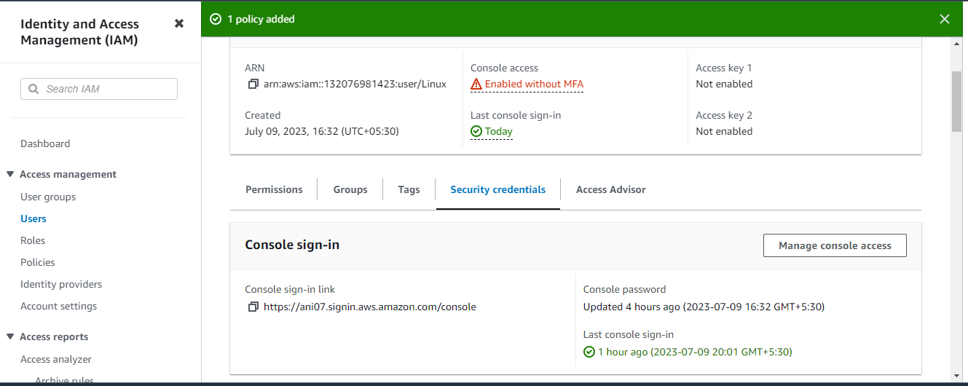

Step 12 :- Now we are user linux account search here s3 service and go there.

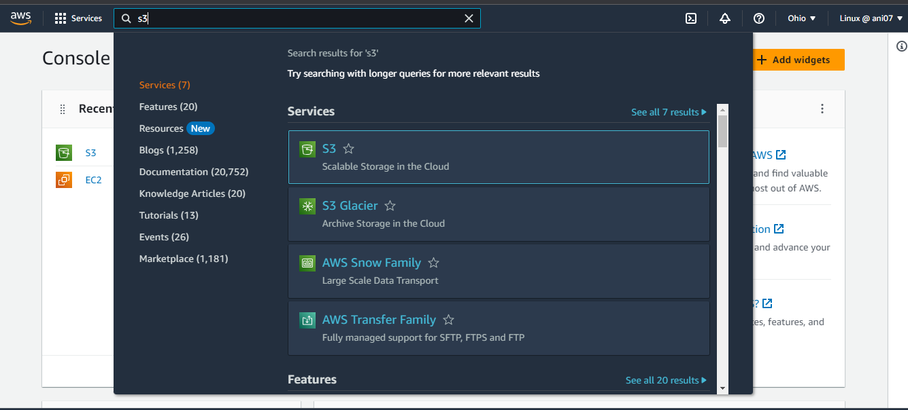

Step 13:-Now see the see bucket demo data u can access it only demo bucket.

You access of only demo bucket cotain read.

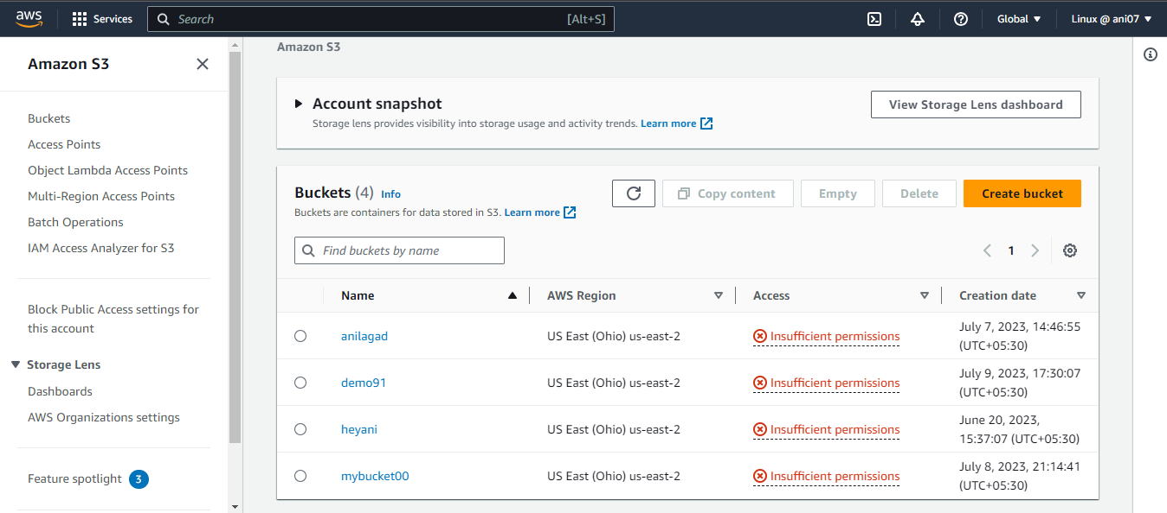

Q 4.Host static website and manage log.

🡺 Step 1:- Go to the s3 service and create bucket ‘Mybucket’. But bucket creating time u want to gave a acl permission and also gave the public access.

Step 2:- Then go to the ‘mybucket’ bucket.

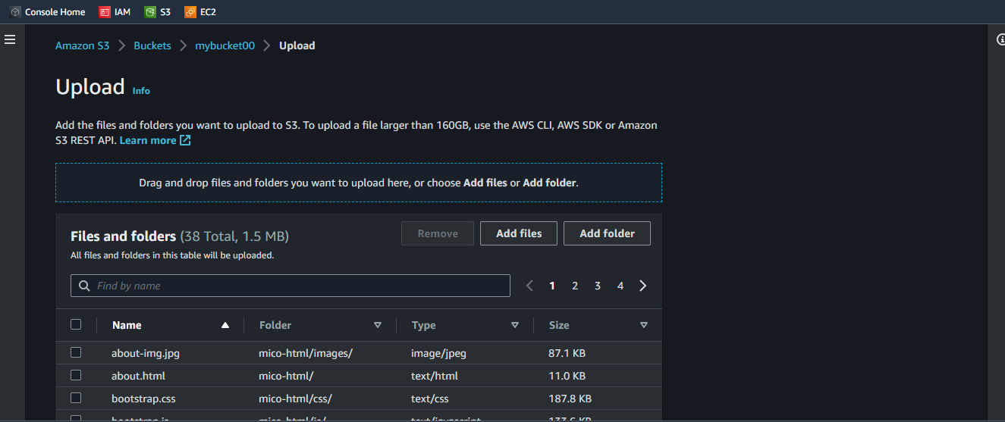

Step 3:- Upload a files for hosting a page it means html failes ex.index.html,error.html etc. and all its related files which host our page.You can add 1 by 1 files or drag drop or direct folder also u upload its on u.

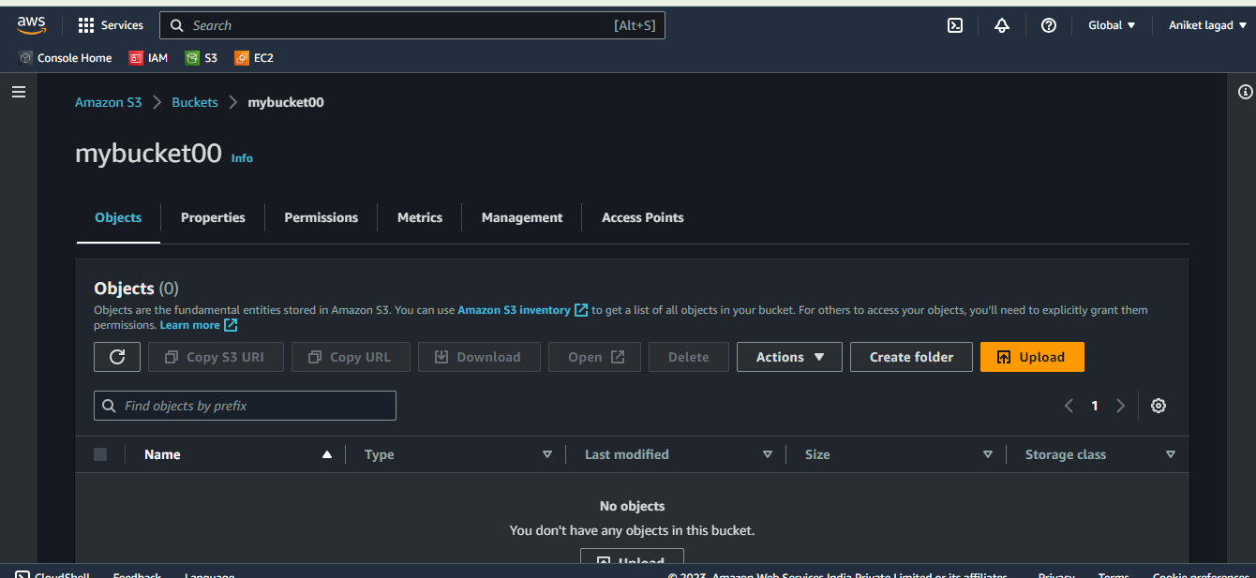

Step 4 :- Then down side u see destination details and then u see bucket versioning if u want create versioning it means u want upload double double files for that.

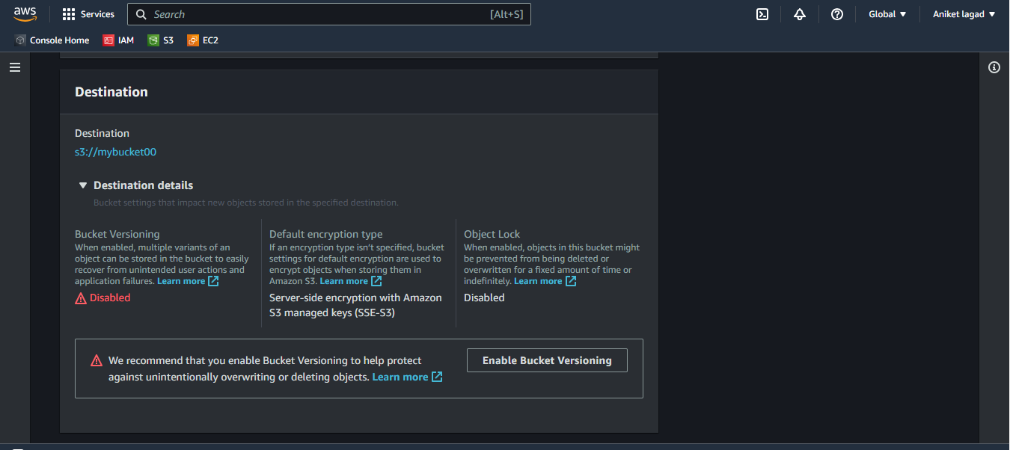

Step 5:- after that u see ACL option by default are they but u want to change then u can.

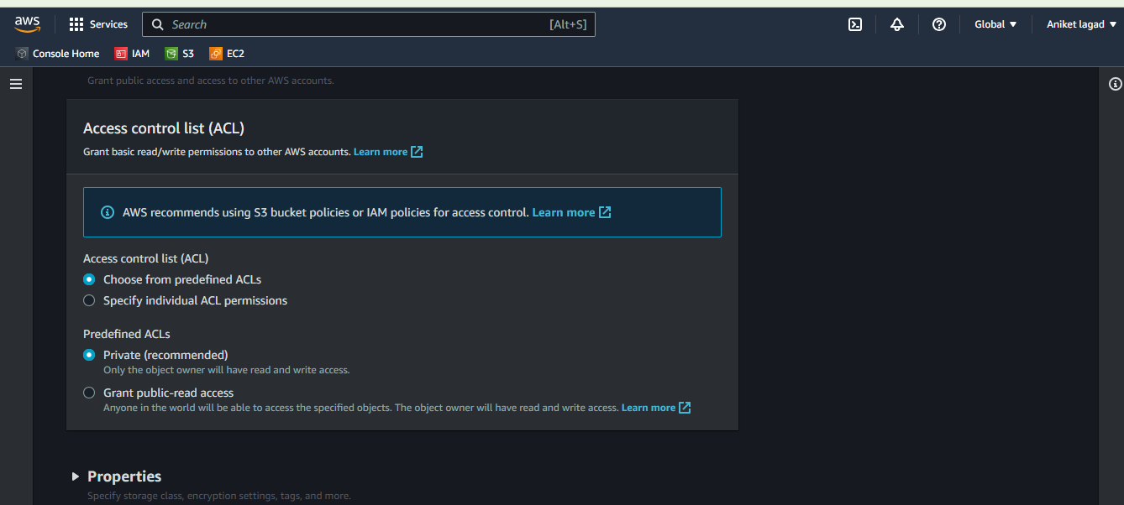

Step 6:- Next u will see properties option it is for aws s3 offers a range of storage classes designed for different use cases it means that data save in different renges also for securite purpose.

After that select upload .

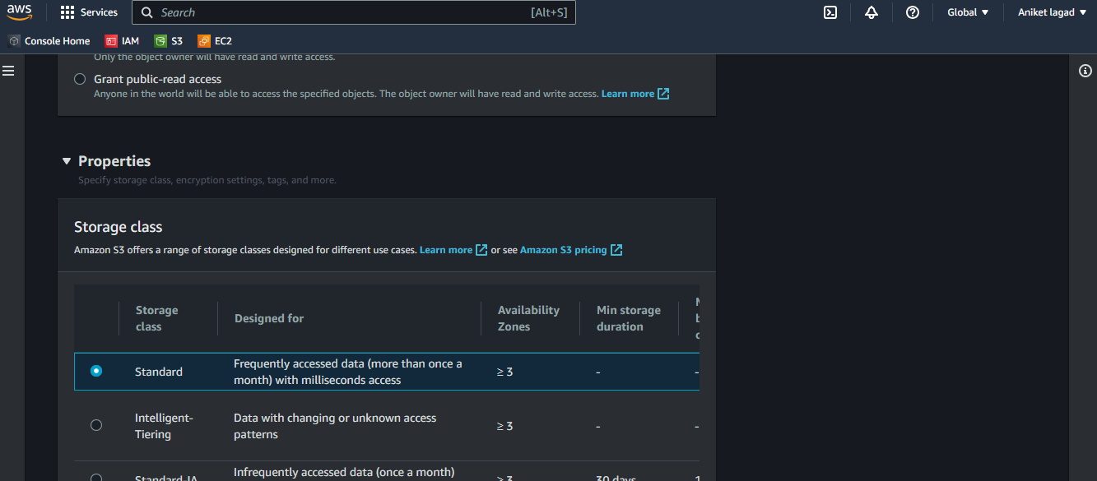

Step 6:- Give it a public access it means select all and then click on actions and select last option make a public using ACl.

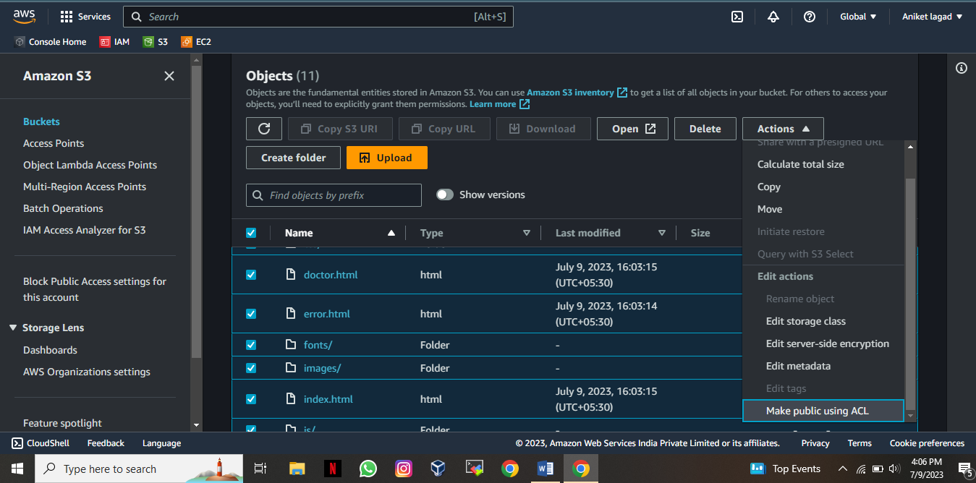

Step 7:- Now u want make it static web so go bucket and click on properties option and scroll down side at the end. And then edit means enabled it.

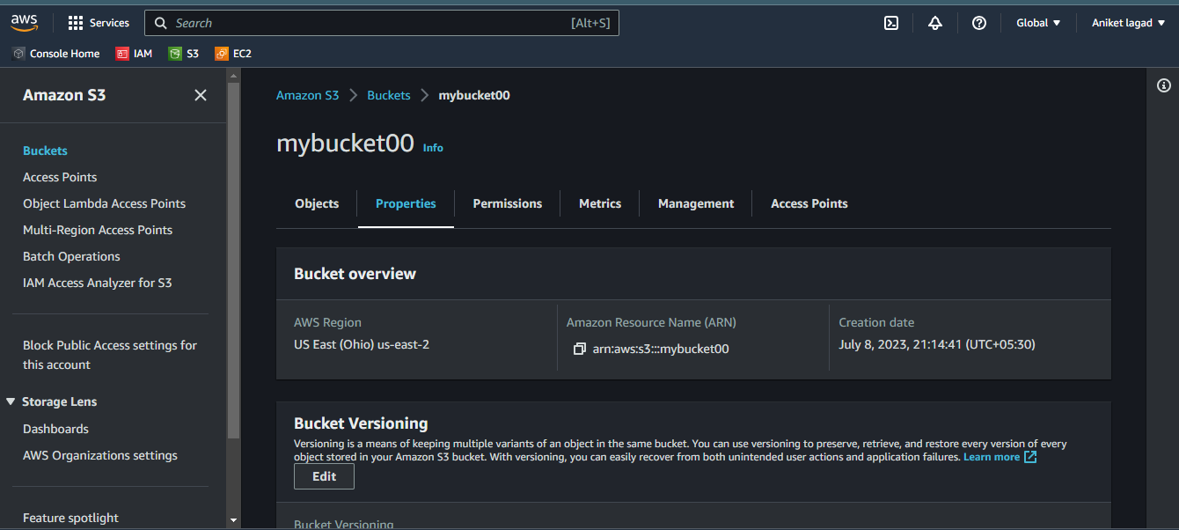

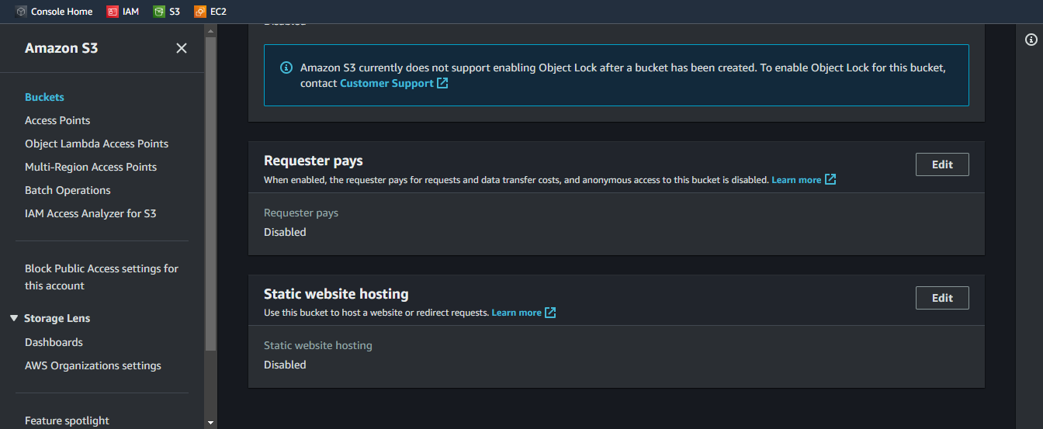

Step 8 :- After u enable it u can see other option hosting type select host a static website option.

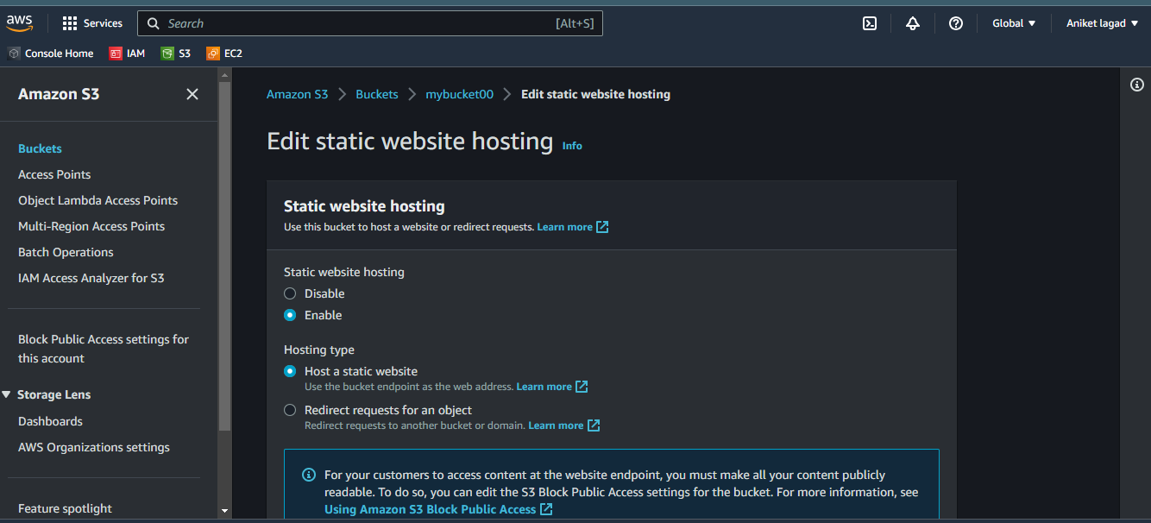

Step 9:- Then index and error document diles names in that columns.Rember index.

Index.html for hosting and error.html is for error occurs.

Now click on last option save changes.

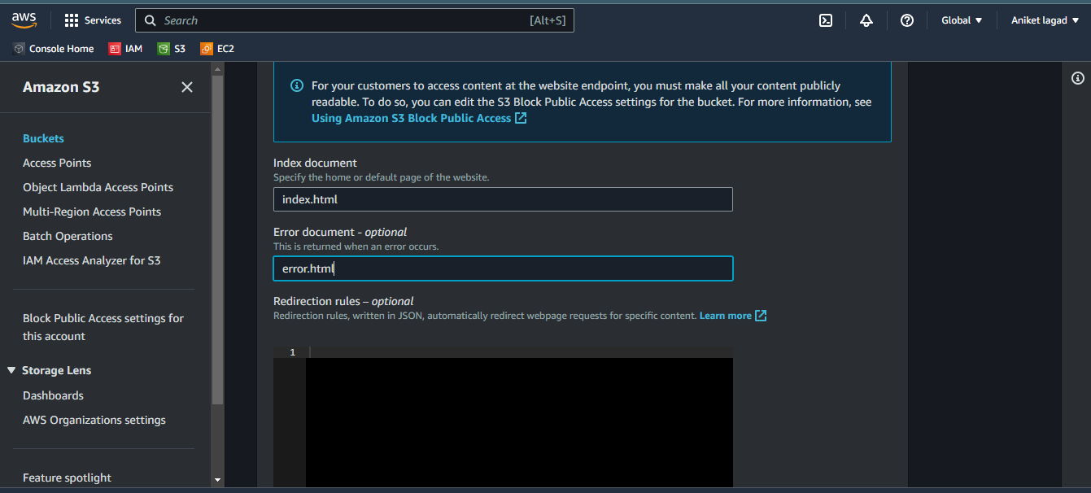

Step 10:- Now u can hosting static website hosting.

Copy bucket website endpoint and send to host.

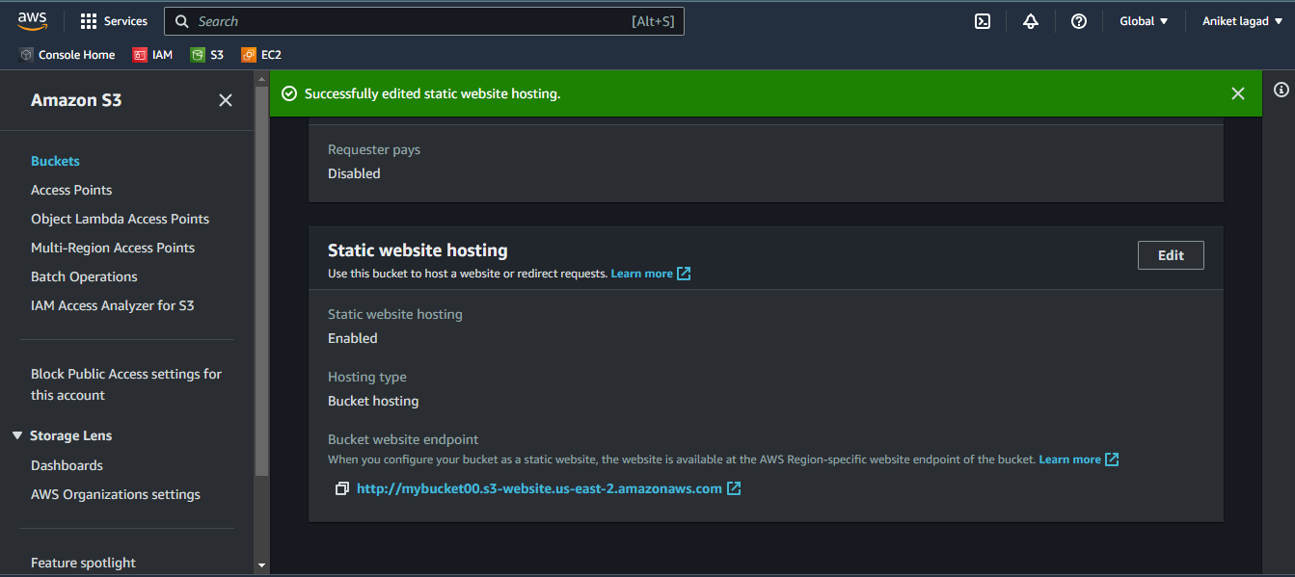

Setp 11:- Now u want manage logs means who is loggin to your page how much loggin etc. all

For that create its logs by enable option sever access logging.

Firstly go to bucket then click on porperties.

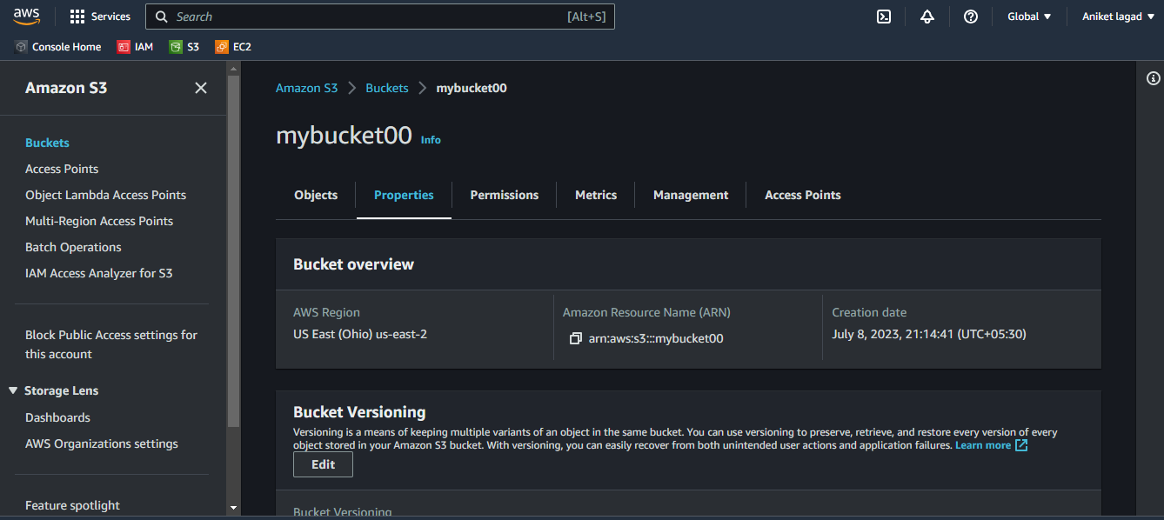

Step 12 :- Now u see option down side or at middle sever access logging option.

Now u want to enable it by click on edit .

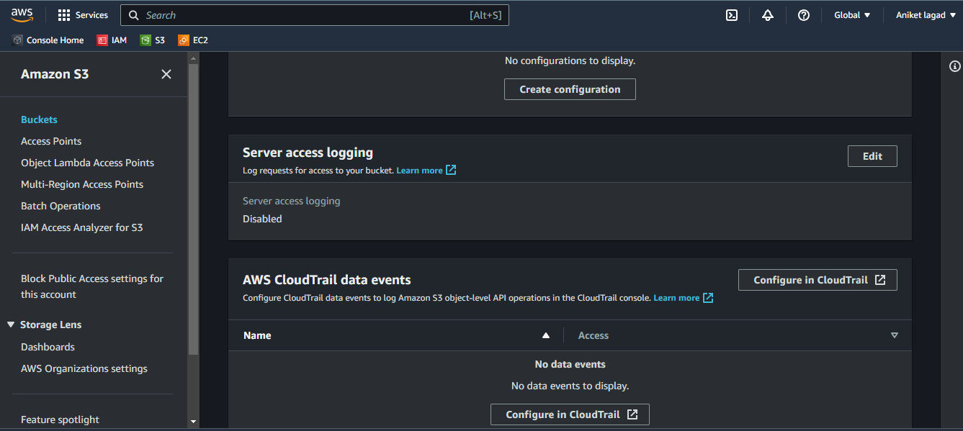

Step 13:-when u enabale it u will see target bucket means u want select bucket destination and then save it by click on save changes option

After that u will see your logs in ur destination bucket .

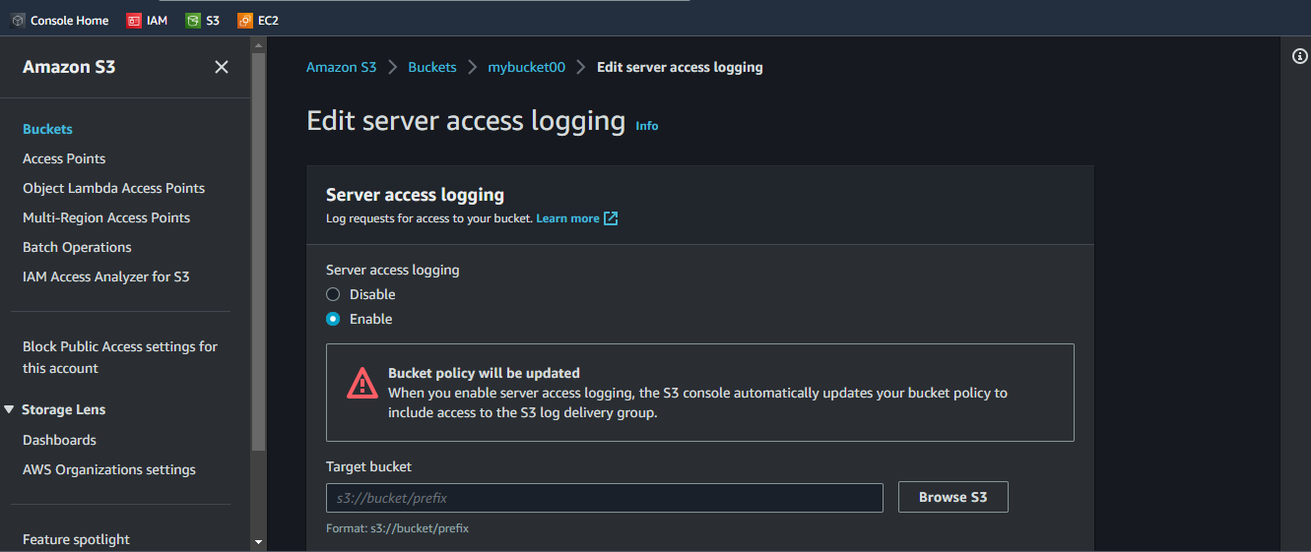

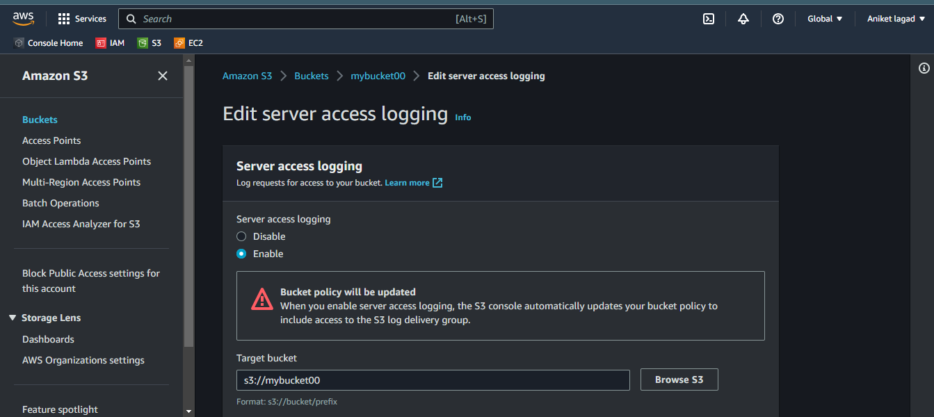

**\*\*\*The End\*\*\***